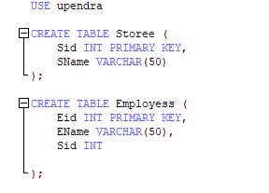Write SQL code to display Recir

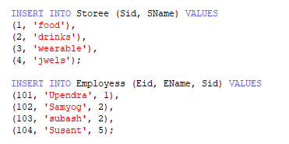

SELECT \*

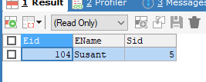FROM Employess e

WHERE NOT EXISTS (

SELECT 1

FROM Storee s

WHERE e.Sid = s.Sid

);